ENGLISH

EMPLOYABILITY SKILLS

1/ Screen Belbin test and 16 Personalities test

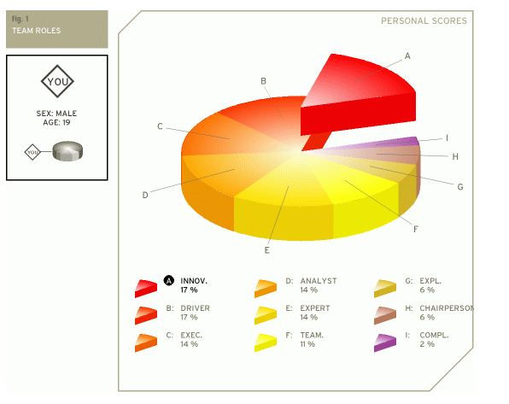

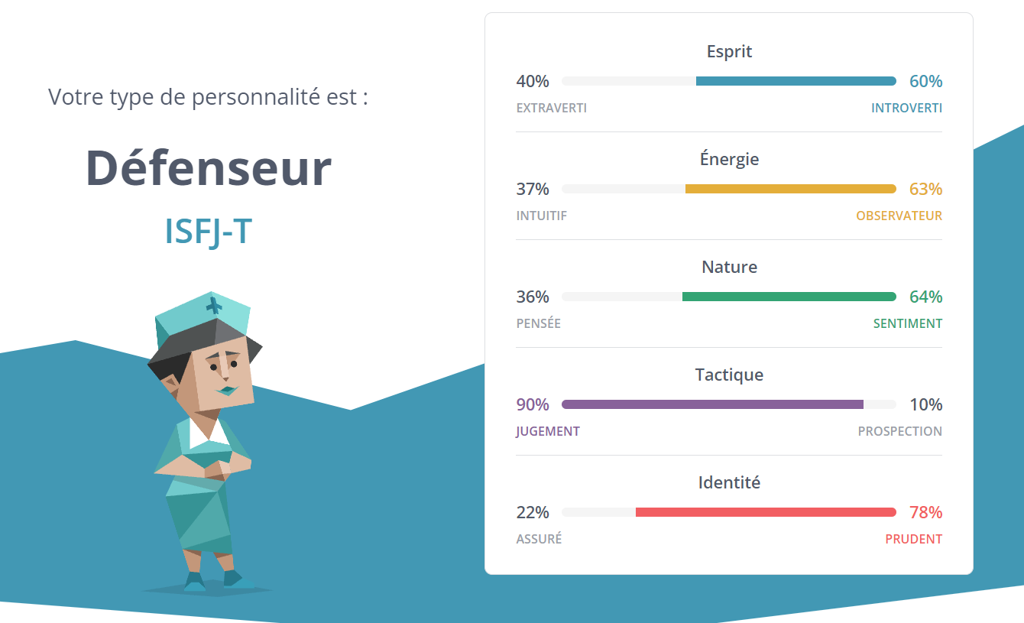

Screen LinkedIn profile in English

Screen of job application in English

Skills :

* MySQL
* PHP
* LAMP
* MVC Programming principles
* Symfony

CV

Motivation Letter

Formal email addressed to Ms Taylor applying for the job

Ms Taylor,

I would like to contact you today to introduce myself for your web developer proposal. Indeed, following BUT Informatique, I am looking for a company more mainly Web with PHP and Symfony, I would like to join your structure for this purpose. I have a good command of web development and graphic design because of my schooling, during which I was able to improve my skills and gain responsibilities.

Please find enclosed my cover letter and my CV

I look forward to your reply.

MILLAN Romain

Preparation of job interview